[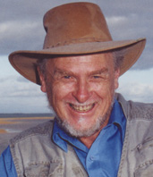](http://creationwiki.org/images/9/93/John_mackay.jpg)